CURRICULUM VITAE

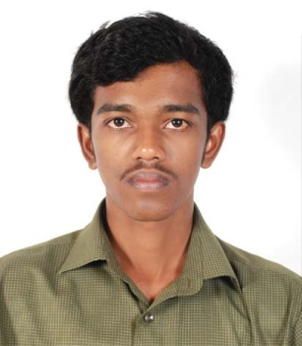
PERMANENT ADDRESS

SHAJI. P
PALLEELAZHIKATHU VEEDU
THEVALAPPURAM P.O.,
PUTHOOR, KOTTARAKKARA
KOLLAM (DIST), KERELA (STATE)
INDIA
PIN-691507

CAREER OBJECTIVES

To exhibit my skills in challenging work environment and Industry, be a positive team player with can do attitude thereby fulfilling my individual role and contribution to the organization growth.

PROFESSIONAL QUALIFICATION
- S.S.L.C : Passed from Board of Public
Examination, Govt. of Kerala
- +2 : Passed from Board of Higher Secondary
Examinations, Govt. of Kerala
- Diploma in Mechanical
Engineering : Completed from Technical Education
Department, Govt. of Kerala

EDUCATIONAL DETAILS

Course |  | University/Board | Institution | Year Of Passing | Percentage Of Marks
- S.S.L.C |  | Kerala Board | G.H.S.S. Puthoor | 2004 | 86
- H.S.E |  | Kerala Board | G.H.S.S. Puthoor | 2006 | 81
- Diploma in Mechanical eng. |  | Technical Education Board | N.S.S P.T.C Pandalam | 2011
 | S1&S2 |  |  |  | 54
 | S3 |  |  |  | 62
 | S4(not passed) |  |  |  | 51
 | S5 |  |  |  | 82
 | S6(not passed) |  |  |  | 45

COMPUTER SKILLS

  - AutoCAD 2007 (2D & 3D)

  - Windows XP, Windows 7, Internet, MS Office (Word, Excel, Powerpoint, etc.)

ACHIEVEMENTS

- Conducted a Seminar about Track Design And Safety Analysis
- Group Leader of Project report of Grass Cutter done at N.S.S P.T.C Pandalam in 2011
- Conducted a Training Report of Extraction of Metals & Minerals at KMML, CHAVARA, KOLLAM with 10 days work Experience.

PERSONAL SKILLS & HOBBIES

- Comprehensive problem solving skills.
- Willingness to learn through hard work.
- Positive thinker and Self Confident.
- Listening Music, Traveling, Playing Chess and Reading.

PERSONAL DETAILS

Full Name : SHAJI. P
Father’s Name : Parameswaran Pillai. T. N
Permanent Address : Palleelazhikathu Veedu,
Thevalappuram P.O.,
Puthoor, Kottarakara,
Kollam (Dist), Kerala (State)
India
Pin:-691507

Contact No. : +914742417349
+919846898564
E-mail : sprvirus46@gmail.com
sprvirus46@yahoo.com

Date of Birth : 08.10.1989
Languages Known : English, Hindi, Tamil & Malayalam
Religion/Cast : Hindu / Nair
Nationality : Indian
Marital Status : Unmarried
Interest : Maintaining good relationship with others

DECLARATION

This is to declare that all the above details are true to the best of my knowledge

Date: 10/09/2011 Thanking You,

Place: Puthoor Shaji. P

